**Module-1**

**1. What is SDLC?**

The full form of SDLC is Software Development Life Cycle. SDLC is a process designed to develop software or websites. This process is carried out step by step. The main parts of this process are as follows:

1. Requirement Analysis

In this phase, the client's needs are identified. It is determined what type of software or website is to be developed and whether it is technically feasible.

2. Information Gathering

In this step, detailed information is collected from the client about the kind of software they require.

3. Design

In this phase, the design of the software or website is prepared. It outlines how the software will look and function.

4. Project Architecture

In this step, the architecture of the software is planned. It includes the estimated time and cost for development and the type of team or resources required.

5. Development

In this phase, the actual software is developed through coding, based on the design and planning.

6. Maintenance

After the software is developed, any problems or bugs that occur are resolved in this phase. Ongoing support and updates are provided as needed.

**2. What is Software Testing?**

Software testing is the process of evaluating a software application to ensure that it functions correctly and meets the client's requirements. It involves identifying bugs, issues, or vulnerabilities, and verifying the performance, reliability, and security of the software.

There are two main types of software testing:

1. Manual Testing – Testing performed manually by testers without using automation tools.

2. Automated Testing – Testing carried out using automated tools and scripts to increase efficiency and coverage.

**3. What is agile methodology?**

The process that works according to the agile model is called the agile methodology. For example, if a project is divided into multiple sprints and work is done according to those sprints, then the process is called the agile methodology.

**4. What is opps**

Oops full form is Object-Oriented Programming System.

This is a programming method in which the method of a program is described as an object.

**5. Write Basic Concepts of oops**

Opps main Concept

1.Class

2.Object

3.Inheritance

4.Encapsulation

5.Polymorphism

6.Abstraction

**6.** **What is object**

Object is one kind of veriabale store a multipal data at a time.

**7.** **What is class**

Class is collection of method, object, variables, constructor and datatype

**8.** **What is encapsulation**

Encapsulation is wrapping the data. Example: method inside a class and data inside a method

**9. What is inheritance**

Inheritance is child class can use functionality of parent class using extend key word

**10. What is polymorphism**

One interface multiple implementation

1 -method overloading - 1 class - more than 1 method -name same - data diff (parameter)   
2 - method overiding  - 1 class - more than 1 method - name same and data same

11. Draw Usecase on online bill payment system (paytm)

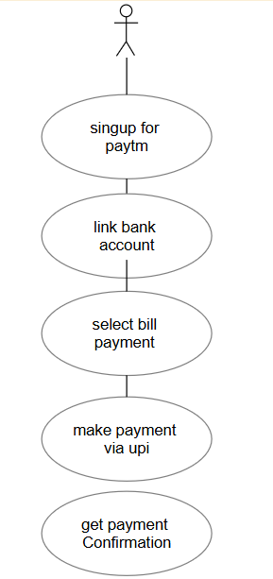

**12.** **Draw Usecase on banking system for customers.**

**13.write SDLC phases with basic introduction**

1. Requirement Analysis

In this phase, the client's needs are identified. It is determined what type of software or website is to be developed and whether it is technically feasible.

2. Information Gathering

In this step, detailed information is collected from the client about the kind of software they require.

3. Design

In this phase, the design of the software or website is prepared. It outlines how the software will look and function.

4. Project Architecture

In this step, the architecture of the software is planned. It includes the estimated time and cost for development and the type of team or resources required.

5. Development

In this phase, the actual software is developed through coding, based on the design and planning.

6. Maintenance

After the software is developed, any problems or bugs that occur are resolved in this phase. Ongoing support and updates are provided as needed.

**14.Explain phases of the waterfall model**

1. Requirement Analysis and info gathering

In this phase, the client's needs are identified. It is determined what type of software or website is to be developed and whether it is technically feasible.

2.System Design

In this phase, the design of the software or website is prepared. It outlines how the software will look and function.

3.Devlopment

In this phase, the actual software is developed through coding, based on the design and planning.

4.Testing

In this phaseTest the developed software to find and fix bugs.

5.Deployment

In this phase developed software live on server for user use.

6.maintenance

After the software is developed, any problems or bugs that occur are resolved in this phase. Ongoing support and updates are provided as needed.

**15.write phases of spiral model**

1.planing phase

2.Risk analysis phase

3.Devlopment phase

4.Testing phase

5.customer Review phase

**16.write agile manifesto principles**

Customer satisfaction through early and continuous delivery

**17.Explain Working methodology of agile model and also write pros and cons.**

Agile model works

1.project breakdown into sprints

The project is divided into small part called sprints

2.Requirement Gathering

Requirements are collected at a high level initially, and detailed requirements are gathered before each sprint.

3.sprint planning

At the start of sprint the team plans which features to build

4.Devlopment

Developers code the selected features within the sprint timeline.

5.Daily scrum meeting

A short daily meeting helps the team stay correct coding and work.

6. testing

Testing is done simultaneously with development.

7. sprint review

At the end of the sprint, the working software is demonstrated to stakeholders.

8. next sprint start

Based on feedback, changes may be made, and a new sprint begins.

**Pros of Agile Model**

1.customer satisfaction

2.Flexiblity to changes

3.Fast delivery

4.improved team collaboration

5.Transparency

**Cons Of Agile Model**

1.Required Experiencd team

2.Expencive

3.Frequent customer involvement needed

18. **Draw usecase on OTT platform**

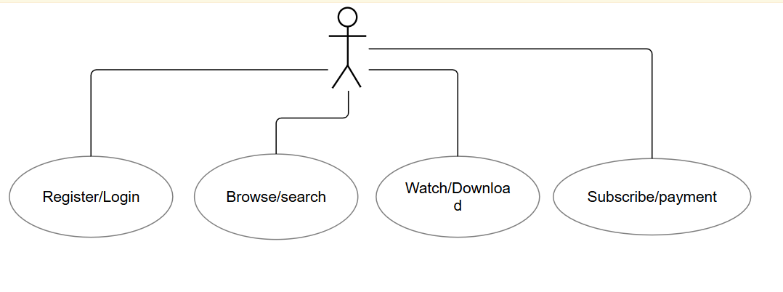

**Module-4**

**1. What is RDBMS?**

RDBMS stands for Relational Database Management System. It is a type of database management system that stores data in a table format, consisting of rows and columns. This structure helps organize data efficiently and allows for easy retrieval and manipulation.

Key Features of RDBMS:

1. Table:

Data is organized into tables, which provide a structured format for storing information.

2. Primary Key:

A primary key is a unique identifier for each record in a table. It ensures that no duplicate records exist.

3. SQL (Structured Query Language):

SQL is the standard language used to manage and query data in an RDBMS.

Example SQL Query (to insert data into a table):

INSERT INTO Students (ID, Name, Age) VALUES (1, 'John', 20);

**2. Write a query to create the table in Structured Query Language.**

I'm creating a table to store university student data like EnrollmentNumber, Name, Address, Stream, Email, and Passout.

CREATE TABLE StudentDetails(

EnrollmentNumber INT AUTO_INCREMENT NOT NULL,

Name VARCHAR(50) NOT NULL,

Address VARCHAR(50) NOT NULL,

Stream VARCHAR(20) NOT NULL,

Email VARCHAR(20) NOT NULL,

Passout VARCHAR(20)NOT NULL,

PRIMARY KEY(EnrollmentNumber)

);

**3. Write a Query To insert data into table with validations.**

INSERT INTO StudentDetails (Name, Address, Stream, Email, Passout)

VALUES

('Ritesh', 'Gandhinagar', 'Computer Science', 'ritesh@example.com', '2023'),

('Mayur', 'Ahmedabad', 'Electronics', 'mayur@example.com', '2022'),

('Parth', 'Ahmedabad', 'Mechanical', 'parth@example.com', '2024'),

('Priyansh', 'Ahmedabad', 'IT', 'priyansh@example.com', '2023');

('Udit', 'Ahmedabad', 'IT', 'udit@example.com', '2023');

4. Write a query to update data into table with validations.

UPDATE StudentDetails

SET

Name = 'Amit Kumar Sharma',

Email = 'amit.sharma2023@example.com',

Passout = 2023

WHERE EnrollmentNumber = 1;

5. Write a query to Delete data from table with validations.

DELETE FROM StudentDetails

WHERE EnrollmentNumber = 3;

6. Write a query to drop table and database.

FOR DATABASE:-

DROP DATABASE University

FOR Table:-

DROP TABLE Studentdetails

**Module-5**

1. What is automation testing

Automation testing is a process in which testing is done with automation tools based on test cases. It is called automation testing.

2. Which Are The Browsers Supported By Selenium Ide?

Selenium IDE (Integrated Development Environment) is a record and playback tool mainly used for browser automation.

1.**Google Chrome**

2.**Mozilla Firefox**

3.**Microsoft Edge**